 **12 June 2015** **The Weekly Bulletin of Rotary Club of Kathmandu Mid-Town** **bc-44/6.015**

|  |
| --- |
|  |

District: 3292 Web:www.rotarymidtown.org.np Club Id: 26776

**JUNE IS THE ROTARY FELLOWSHIPS MONTH**

***June is designated Rotary Fellowships Month to recognize the importance of international fellowship and goodwill among Rotarians with similar recreational and vocational interests, promote increased participation***

***in fellowships, and increase understanding of this program.***

***The RI Board encourages these groups to celebrate Rotary Fellowships Month through projects, activities, and events.***

Club’s Weekly Meeting # 1282 on 5 June:

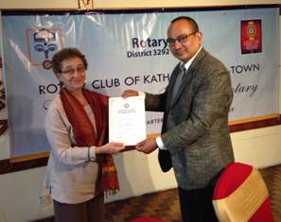

IPP Saroj providing a certificate of Appreciation to Guest Speaker Ms Judith Amtzis

*Photo Courtesy:* Rtn Shyam R Thapaliya

Extracts of the Minutes # 1282

“1. IPP Rtn Saroj called meeting #1282 to order

“3. He welcomed members and guest: Rtn Dave Boon (RC Fort

Collins After Work) and daughter Denali and visiting Rotarian

Sudip Koirala (RC Rudramati) and Ms Laxmi Shrestha (Sister-

in-law of PP Gopal).

”7. Speaker Judith Amtzis. Title of Talk: Increasing Equality for

Buddhist Nuns. Sec Isa gave the introduction. Ms Amtzis began

by explaining Buddhism has developed in societies that are

predominantly patriarchal, and the status of nuns has generally

been lower than that of monks. To begin to remedy this, the

17th Karmapa Rinpoche recently announced that he was

beginning a process that will ultimately lead to full ordination

for nuns, giving them the same status as monks. This has not

existed in the Vajrayana tradition for over 900 years. Something

similar happened in 1892 when the first Tsoknyi Rinpoche

opened a nunnery in Eastern Tibet that provided nuns with the

same opportunities for Buddhist study and practice as monks

enjoyed. Just last year, the third Tsoknyi Rinpoche announced

that he was continuing that tradition here in Nepal, at the Tsoknyi Gechak Ling nunnery in Chobhar. Rtn Rabi gave the vote of thanks.

”8. Information sharing:

> Rtn Askko will be returning to Finalnd for retirement. A 'farewell' card was circulated for him. Rtn Askko sent an

email saying how much he had enjoyed his time at RC Mid-Town.

> Sec Isa read out the list of donations that had come from abroad this week.

> PP William reported on the donation of 3 PAUL water filtration units and circulated a report with photos.

> Rtn Rabi reported that while in US he had contact with Rotary clubs there who were also fundraising for Nepal's earthquake victims.

> PP Lekha reported on the ongoing work in Kavre – so far 6 families have GI sheets and 48 will get soon. The Rotaracts are also working with volunteers from the Child Haven Orphanage

> Acting Pres Saroj read out a message from Siba Bhakta Rajbhandary, District Grants Sub-Committee Chair who says: Grant projects reports are due within 12 months of receiving the first grant payment and  every 12 months thereafter; Final reports are due within 12 months of project completion. Grant sponsors that have overdue reports will not be able to support new grant application. In this connection, it has come to our notice that RC Kathmandu Midtown report on the following projects are overdue:

Project # Report Due Date

MG 1378232 31 October 2014 - Samapati Water Project – pumping water uphill to community – Single

Women Centre Chhahari,Kavre, RC Plymptom, UK – Rtn Peter Reid;

MG 1377952 13 January  2015 - Early Childhood Development Program - Schools in Sindhupalchok

RC Oldmeldrum, Scotland RID-1010;

GG 1415715 11 February 2015 – Training for teachers of schools in Sindhupalchowk with early childhood

program. More than 200 teachers benefited - RC Oldmeldrum, RID-1010

Scotland;

MG 1379679 31 March 2015 - Bio Gas Project, Parsauni, Nawalparashi - RC of Borken, Germany RID-1870,

Rtn Remy Einhaus.

> Exchange of flags with Rtn Dave Boon (RC Fort Collins After Work) and Rotarian Sudip Koirala (RC Rudramati) Rtn Boon said that he had enjoyed his time in Nepal and that he would continue fund raising and working for Nepal in Colorado. He will be back in the fall.

“9. Statistics of the meeting: Members present: 21”

# Weekly Meetings and Programs :

|  |  |  |
| --- | --- | --- |
| Date | Program/ Speaker | Topic of Presentation |
| 12 June | Dr Aruna Upreti |  |
|  |  |  |

Weekly Meeting on Friday, 12 June:

**RC Kath Mid-Town quick Board Meeting on 12 June Friday morning**

Dear Mid-Town Board 2014-15:

Pres Kul Chandra requests us to attend a quick Board Meeting after the breakfast meeting on Friday June 12. He will be travelling again and would like to see that any outstanding matters are settled.

**Past Presidents’ Meeting on 5 June Friday morning**:

PP Komal Chitracar, Chair/TRFC, summarizes on matters regarding delay in implementing the Bio-gas project:

“I read with interest the concern on the subject as recorded in the minutes of the RC Borken meeting on 26.05.2015. I highly appreciate Remy's response vide his mail dated 01.06.2015. He has understood the issue in the right perspective. He has expressed his trust on the ability of our club to handle the project successfully and also explained the reasons of the perceived delay in completing the project. In fact, he is all praise for the good work that our club has being doing. I felt upon reading his response that he does not have any doubt on the efficiency and effectiveness of our performance.

“Service project committee chair Rabi and the prime contact for the project Pramod explained the matters as Remy stated in his response.

“First, there was delay in reaching the fund in our club and that was not our fault.

“Second, it took time to select the location of the project. Finally it was decided to have it in the village of our member Pabitra Jung Raymajhi. It is not possible for the contact person to visit the project as the site is not very close to Kathmandu. Pabitra volunteered to supervise implementing the project.

“Third, the project could not be commenced immediately upon receipt of fund. The contractor was already selected in time. The delay by a few months was due to weather conditions. Waiting for the rainy season to be over, the works did start soon after monsoon. Pabitra did send a progress report with photographs of the works. Pramod is currently trying to contact Pabitra and/ or the contractor to get the up-to-date status. The only difficulty was that he was frequently out of contact due to health or other personal reasons. There was, indeed, some problem in communication, as fast as we expected. Hopefully, the project has been completed by now. We should be getting a clearer picture very soon.

“Fourth, RC Borken should be reassured that RC Kathmandu Midtown is fully accountable for the project fund and its proper use. The club officials are aware of their responsibilities. The required reporting will be done shortly upon collection of information as to the up-to-date status of the project. As for the financial data, the payment made to the contractor so far is only Rs. 1,000,000 and the balance of some Rs.2 million is still with the club which will be disbursed upon receipt of claim after due scrutiny.

“I have summarized the matter for the understanding of all concerned. If I have missed any important point, I request the other concerned persons to add on.”

**District Training Assembly on 13 June 2015**

District Training Assembly is going to be held on Saturday, 13 June 2015 at DAV College, Jawalakhel, Lalitpur.  This is a very important District event and Incoming Club Officials are encouraged to attend the program. The Registration fee will be NRs. 1,500 per participant, which will include Breakfast, Lunch and High Tea.

**District Membership Seminar**

**Date: 14th June 2015 Time: 1:30 pm**

**Venue: Lainchaur Banquet, Lainchaur, Kathmandu**

**Registration Fee: Rs 1,300**

**The program will be followed by dinner.**

**A THOUGHT FOR TODAY:**

**[When flood comes, fish eat ants and when flood recedes, ants eat fish.](http://www.brainyquote.com/quotes/quotes/b/baruchspin101666.html" \o "view quote)**

**[Only time matters. God gives opportunity to everyone!](http://www.brainyquote.com/quotes/quotes/b/baruchspin101666.html" \o "view quote)**

*[Courtesy: Rtn Isabella C Bassignana Khadka](http://www.brainyquote.com/quotes/quotes/b/baruchspin101666.html" \o "view quote)*

**Rotary International Convention in Sao Paulo**



“It is hard work at the Rotary Convention as you can see”, our friend Rtn Bhairaja Panday shares.

**Gurkhas are coming! A fine tribute to 200 years of fierce loyalty:**

They must be the two most welcome (or unwelcome) words on any battlefield: ‘*Ayo Gorkhali*!’ – ‘The Gurkhas are coming!’ For two centuries, they have been revered by their allies – and their enemies’ worst nightmare.

So it was quite a party last night (9 June) as the Brigade of Gurkhas celebrated 200 years of unswerving loyalty to the Crown with a spectacular pageant in front of the Queen, the Sultan of Brunei, the Prince of Wales and other members of the Royal Family at the Royal Hospital Chelsea.

The famously demanding recruitment and selection process for the 3,000-strong brigade featured prominently in the show, as did Gurkha culture, music and dancing (assisted by 45 regimental wives in their finery).

On every mind, though, was the earthquake which struck Nepal in April, killing more than 8,000. Its epicentre was the Gorkha district, the brigade’s spiritual home. The disaster touched every member, past and present; two riflemen are still in Nepal on compassionate leave, helping their families rebuild their flattened homes. Proceeds from last night’s event, which opened with a minute’s silence, will go to earthquake relief and the Gurkha Welfare Trust, of which the Prince of Wales is patron.

The Gurkhas may not be the chattiest of troops, nor the tallest. But they march faster than anyone. And they can still make the loftiest Guardsman walk several inches taller.

As Prince Harry observed after serving alongside the Royal Gurkha Rifles in Afghanistan, there is ‘no safer place’ on Earth than being next to a Gurkha.

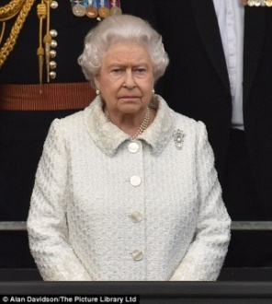 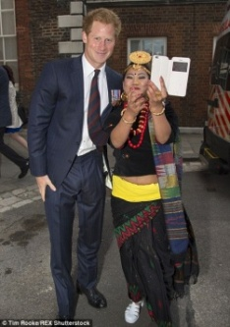 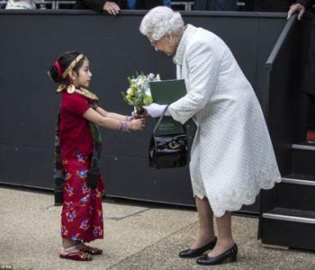 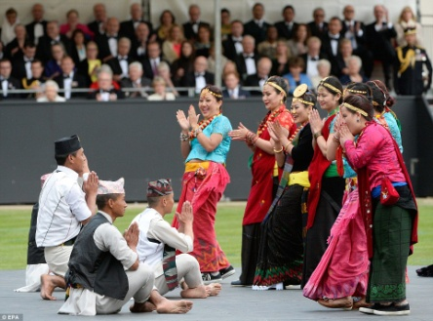

1-The Queen led 1,400 guests in a minute's silence in memory of those who died in the Nepalese earthquake as part of the event;

2-Prince Harry met with serving Ghurka soldiers and their families during the evening;

3-The daughter of a serving Gurkha in the British military, Swechya Joshi (6 yr), gave the Queen a bouquet of flowers at the event;

4-Gurkhas and their wives took part in an evening featuring music and dance.

*More in* <http://www.dailymail.co.uk/news/article-3117535/Gurkhas-coming-fine-tribute-200-years-fierce-loyalty>

Travel / Tourism

**

“The sun set at Artic”

*Courtesy: Dr Isabella C Bassignana Khadka*

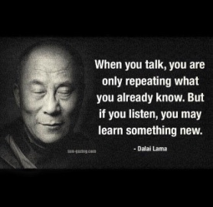



On Lighter Side:

A police officer stops a *gaonle* youth for speeding and asks her very nicely if he could see her license.

She replied in a huff, "I wish you guys could work in coordination with your team.”

Just yesterday you took away my license and then today you expect me to show it to you!

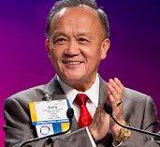

I have seen a new energy in Rotary this year, and felt a new excitement. We've seen more

and more women and young people join Rotary as well.

**RI President GARY C.K. HUANG**

## 12 June 2015 The Weekly Bulletin of Rotary Club of Kathmandu Mid-Town bc-44/6.015

******************************************